MORE ON EMPLOYEE DATABASE

Query 1: Creating and displaying tables
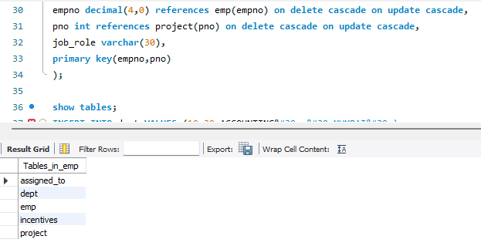
Query 2: Inserting values into tables
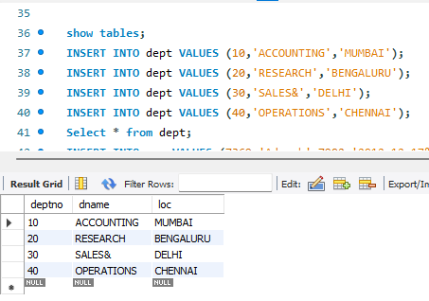
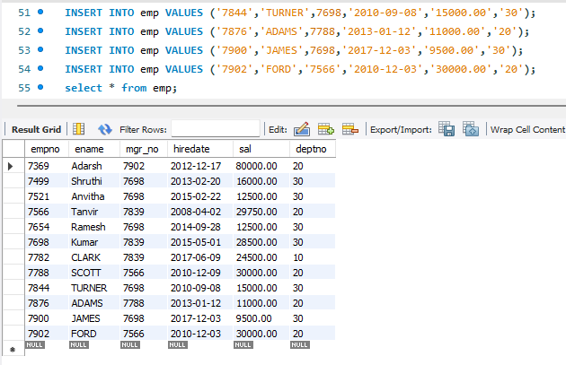
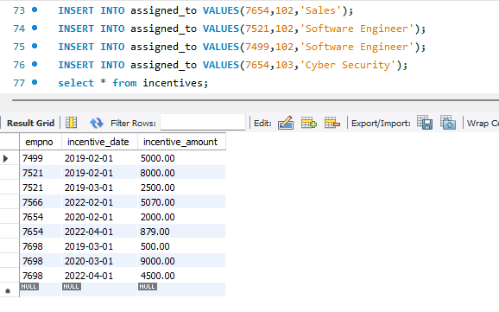
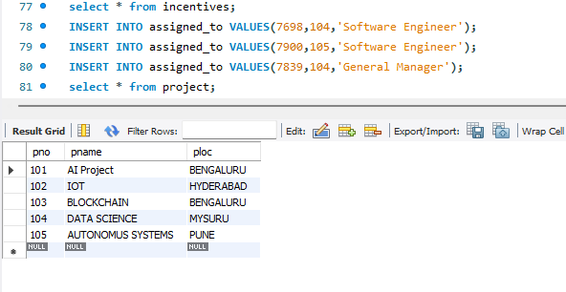
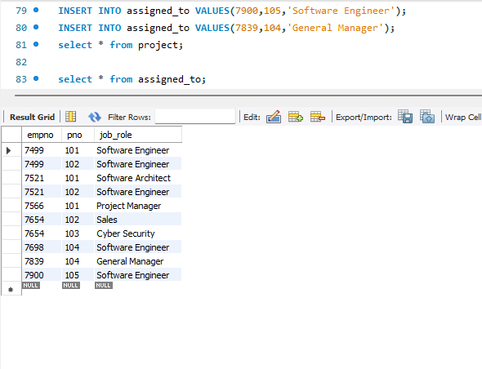
Query 3: List the name of the managers with the most employees
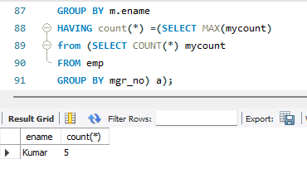
Query 4: Display those managers name whose salary is more than average salary of his employee
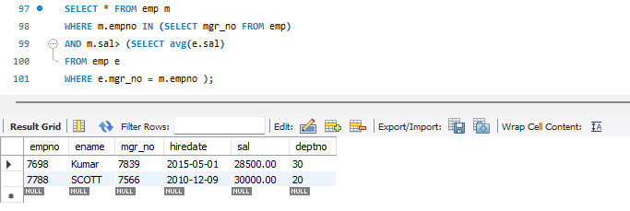
Query 5: Find the name of the second top level managers of each department.
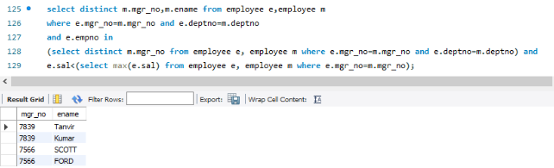
Query 6: Find the employee details who got second maximum incentive in January 2019.
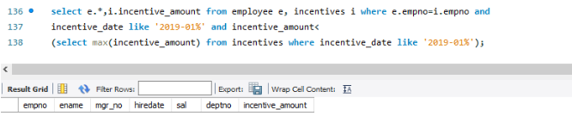
Query 7: Display those employees who are working in the same department where his manager is working.

